UK National Grid: DAY, WEEK, DECADE

Data Analysis of UK Energy Grid & CO2 Emissions

Leo Hayes

Date: 07/03/2023

Contents

Introduction 3

Caveats 3

UK Power Source Share (Monday 19th September 2022) 4

1) Origin of Different Sources of Electricity 4

Methods 4

2) Aggregated Types of Power 5

Methods 5

Total UK Power Demand (Monday 19th September 2022) 6

3) Electrical Power vs Time (24hr) 6

Methods 6

Demand & Avg. Energy (Monday 15th August – 22nd August 2022) 7

4&5) Demand vs Time (Week) 7

Methods 7

Decade CO2 Emissions Table (2012-2022) 8

6) Table of CO2 Emissions 8

Methods 8

CO2 Emissions Plots (2012-2022) 9

7) Plot(s) of Emissions Table 9

Methods 9

CO2 Emissions (omitting Coal & Gas) 10

Methods 10

Conclusion 10

References 11

Appendices 12

Plots 12

Code 13

1 & 2) 13

3) 14

4 & 5) 14

6 & 7) 15

Files 18

Figure 1 - Origin of Total UK Power Sources 5

Figure 2 - Aggregate share of Total UK Power 6

Figure 3 - UK Grid Demand 24hrs 7

Figure 4 - Demand w. Overlay over week period 8

Figure 5 – In MATLAB (Table 1 & 2) 9

Figure 6 - Total CO2 Emissions (Kilotonnes) 2012-2022 9

Figure 7 - Total CO2 Emissions 2012-2022 10

Figure 8 - Total CO2 Emissions (o. Coal & Gas) 11

Figure 9 - 3D Chart of Cleanest Energy Sources (Extra) 12

UK National Grid: DAY, WEEK, DECADE

# Introduction

This report is an analysis of data from the UK National Grid. The report will cover different types of data for different timescales. This data was acquired from GridWatch, a SQL database of UK National Grid and interconnector sources. Using the downloaded statistics, useful data will be extracted and studied to see if any patterns emerge that can be commented on. In 2008, the UK government brought into law a requirement to reach net zero emissions by 2050. Hopefully, the data should reflect that commitment.[1]

# Caveats

Although the creator of GridWatch expresses how the site has gained improvements to its accuracy, there are some statistics that are based on estimations. The following caveats must be considered:

* Renewables are cleaner than fossil fuels however there is no silver bullet, they still have social, economic and CO2 emission impacts.[2]
* Units of electricity generated by renewable sources will not have an equivalent reduction in fossil fuel usage.[3]
* Demand is recorded by central metering. Actual Demand is higher due to embedded technology such as small wind turbines and domestic solar panels. Solar power is **NOT** included in this data.[4]
* Wind data contains statistics only from *metered* wind farms. See previous.
* The power used to recharge pumped hydroelectricity is **NOT** recorded.
* Solar data is an *estimated* output provided by University of Sheffield. There are reasons to suggest the output is 10% larger.[5]
* OCGT is only used at peak times due to low efficiency compared against its counterpart CCGT.[6]
* Other data represents an unspecific source, possibly STOR capacity such as Diesel.[7]
* Interconnector data is excluded from this report. [8]
* The main software used in this report is MATLAB (see Appendices). Excel has only been used to download and import data.

# UK Power Source Share (Monday 19th September 2022)

## 1) Origin of Different Sources of Electricity

Figure 1 - Origin of Total UK Power Sources. This chart shows most power demand originates from Combined Cycle Gas Turbines (CCGT). Immediately, what can be seen, is Coal now only takes 3% of the share. There is a variety of renewable energy sources that highlights the need to explore alternatives to replace fossil fuels, however, there is a lot of work that remains to compete with the same output as Gas.[9]

### Methods

Instead of showing two charts for total power, a single pie chart was used. Labels were concatenated together to show each source with their percentage. The sources with a percentage of “<1%” were arranged between larger sources so they would not overlap. (see Appendices)

## 2) Aggregated Types of Power

Figure 2 - Aggregate share of Total UK Power. This chart shows aggregated types of power source. Groups were assigned based on fuel type. Fossil Fuels (CCGT, OCGT, Coal, Oil), Renewables (Wind, Solar, Hydro, Pumped, Biomass), Nuclear and Other. Once again, demonstrates that an increase in renewables is necessary. However, the intermittency of renewable energy means that relying on one source is not practical. [10]

### Methods

It was decided based on the information from the data source (see Caveats) to include Pumped and Biomass in the Renewable type. Biomass makes up 7% of the total power share and is renewable.[11] Pumped is a type of hydroelectric energy and although it is a small share, if expanded it will help with reducing intermittency. Similarly, Oil is no longer in use and OCGT is used at peak times (see Caveats) and should not be ignored. [12]

# Total UK Power Demand (Monday 19th September 2022)

## 3) Electrical Power vs Time (24hr)

Figure 3 - UK Grid Demand 24hrs. From this area chart, it is clear to see the impact of the population’s usage of electricity for a 9-5 workday. At night, demand is low as the majority are asleep (except students) but as soon as people are up for work a spike occurs reaching over 28GW. This then drops as people have their lunch at midday and then peaks higher to almost 31GW when they head home (rush hour). According to other reports demand profiles have reduced since 2006, the data reflects that reduction. [13]

### Methods

Demand was in MW and was divided by 1000 to correct the axis range. A limit was created on the y-axis to ensure a useful plot. (see Appendices)

# Demand & Avg. Energy (Monday 15th August – 22nd August 2022)

## 4&5) Demand vs Time (Week)

Figure 4 - Demand w. Overlay for week period. This chart is almost the same as Figure 3 except repeated for different days. With the average bar overlay it is easy to identify the working week; 5 days on, 2 days off. The middle of the week being the peak of demand while Sunday being off-peak. Based on a 2014 study, the above figure more closely resembles its winter demand; the study revealed summer highs of 50GW compared to the 32GW seen above, showing a reduction since then. [14]

## Methods

Plotting demand over time was not difficult. The challenge arose with the bar chart overlay; creating a group of averages to represent each day. The solution was to use *mat2cell()* function to create a vector of vectors, to calculate the average of each day *cellfun(@mean, sub_vector)* was used. Assigning the *xtick* values to a variable allowed the bar chart to be correctly aligned with the middle of each day. To show the first plot behind, the overlay’s settings were adjusted to be translucent.

# Decade CO2 Emissions Table (2012-2022)

## 6) Table of CO2 Emissions

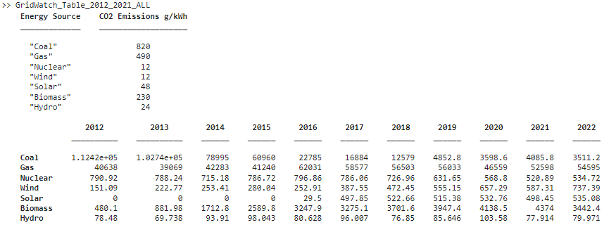

Figure 5 – In MATLAB (Table 1 & 2)

|  |  |  |  |  |  |  |  |  |  |  |  |
| --- | --- | --- | --- | --- | --- | --- | --- | --- | --- | --- | --- |
| Energy Sources | CO2 Emissions (Thousands of Tonnes) | | | | | | | | | | |
|  | **2012** | **2013** | **2014** | **2015** | **2016** | **2017** | **2018** | **2019** | **2020** | **2021** | **2022** |
| **Coal** | 112420 | 102740 | 78995 | 60960 | 22785 | 16884 | 12579 | 4852.8 | 3598.6 | 4085.8 | 3511.2 |
| **Gas** | 40638 | 39069 | 42283 | 41240 | 62031 | 58577 | 56503 | 56033 | 46559 | 52598 | 54595 |
| **Nuclear** | 790.92 | 788.24 | 715.18 | 786.72 | 796.86 | 786.06 | 726.96 | 631.65 | 568.8 | 520.89 | 534.72 |
| **Wind** | 151.09 | 222.77 | 253.41 | 280.04 | 252.91 | 387.55 | 472.45 | 555.15 | 657.29 | 587.31 | 737.39 |
| **Solar** | 0 | 0 | 0 | 0 | 29.5 | 497.85 | 522.66 | 515.38 | 532.76 | 498.45 | 535.08 |
| **Biomass** | 480.1 | 881.98 | 1712.8 | 2589.8 | 3247.9 | 3275.1 | 3701.6 | 3947.4 | 4138.5 | 4374 | 3442.4 |
| **Hydro** | 78.48 | 69.738 | 93.91 | 98.043 | 80.628 | 96.007 | 76.85 | 85.646 | 103.58 | 77.914 | 79.971 |

Figure 6 - Total CO2 Emissions (Kilotonnes) 2012-2022. From the table alone it is hard to recognise practical info. Examine the plots below.

## Methods

It was challenging to use MATLAB with such a large data set. Several methods were devised but then discarded. The main difficulty was representing yearly values as each year was of a different length, this includes leap years. The solution was to create a vector of year values and measure the occurrences of each year, this was then stored as a control and called ina function (see Appendices). Instead of storing each total column in a separate vector they were each transposed and inserted into a 7x11 matrix labelled “Megawatts”. The numbers in g/kWh from Table 1 were converted to Kilotons/MWh using dimensional analysis, the period between each data point was 5 minutes, and the totals matrix was measured in megawatts.

$$Kilotonnes=\frac{\frac{g}{kWh}}{1*{10}^{6}MWh}*MW*h$$

It was practical to go over the above equation and create a new matrix with the CO2 emissions for each year using a for loop.

# CO2 Emissions Plots (2012-2022)

## 7) Plot(s) of Emissions Table

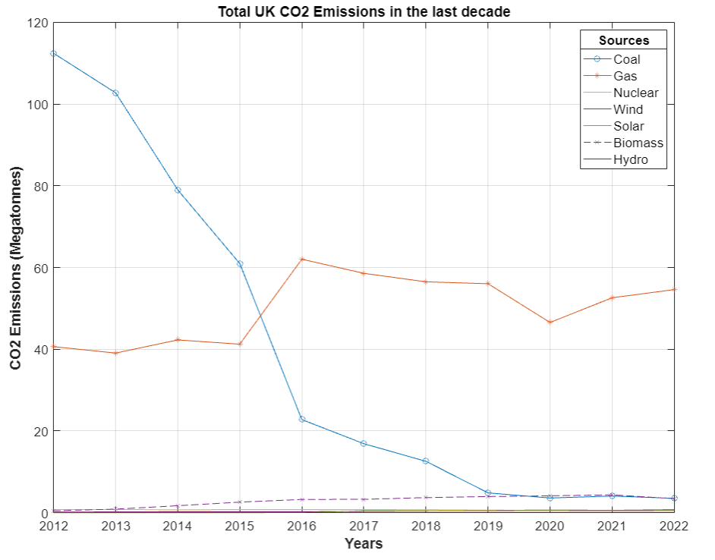Figure 7 - Total CO2 Emissions 2012-2022. It is obvious to see that fossil fuels like Coal and Gas are the biggest polluters. The use of gas for fuel has increased (notice the switch to Gas around 2015 [15] and impact of Covid in 2020) yet there has been a reduction in coal usage in the last 10 years which should be an important milestone for net zero targets. Some may argue that using renewable energy instead of gas would make achieving net zero faster, as well as diversifying energy sources and reducing dependency on one resource. The war in Ukraine has shown how much of a danger that can be. [16] [17]

### Methods

Plots were created, and their settings changed to show different line styles and markers to differentiate each plot. A legend was added to identify each energy source.

## CO2 Emissions (omitting Coal & Gas)

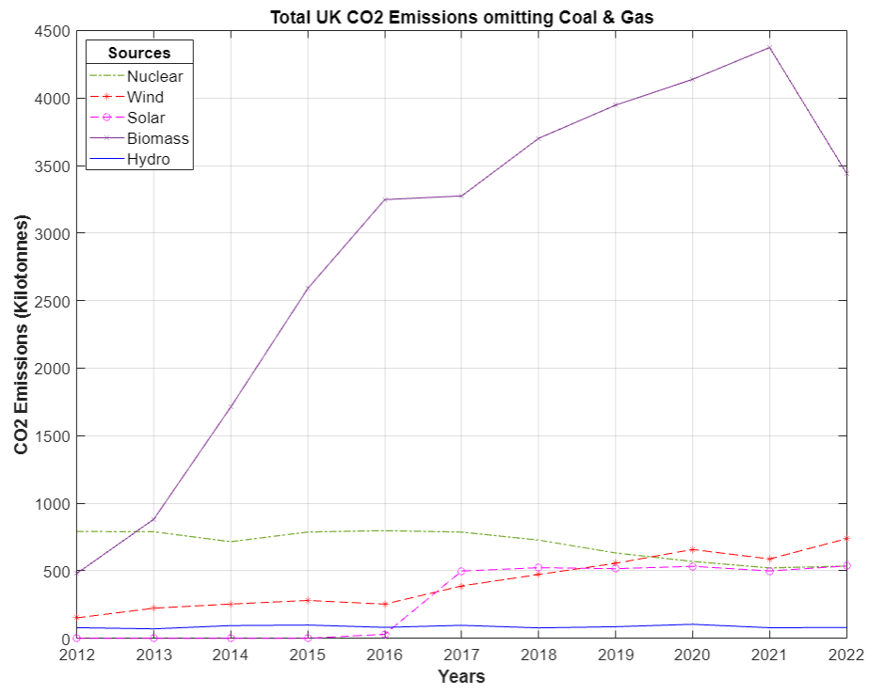Figure 8 - Total CO2 Emissions (o. Coal & Gas). By removing Coal & Gas from the chart it is easier to see the values of the other sources. Biomass has seen a sharp increase in emissions since 2012. However, this is due to more people using the resource.[18] Nuclear has seen a steady decrease of emissions in the last decade because of improved technologies making nuclear production cleaner. [19] Wind has had a steady increase which is due to higher production. [20] Solar power begins in 2016, however because this is an estimate, there might be no data before that time. (see Caveats).

### Methods

(see Part 7 Methods).

# Conclusion

The objective of this report was to find if patterns in the data reflected a commitment to net zero targets. In the last 10 years, there has been a large reduction in coal usage and demand overall, however, the reduction of fossil fuels leaves a lot to be desired, shown by the increase in CO2 emissions from burning gas. The analysis of energy types revealed a varied range of renewable energy sources. Renewable energy has the issue of being intermittent; however, as technology has improved, this could be addressed by increasing funding for varied renewable energy and improved power storage.

# References

[1] Climate Change Committee, *A legal duty to act: The 2050 Target.* [Internet].London. c2023. [cited 2023 Feb 15]. Available from: <https://www.theccc.org.uk/what-is-climate-change/a-legal-duty-to-act/>

[2] Mumenthaler, C., *A silver bullet won’t solve a green problem.* [Internet]. Geneva. 2020. [cited 2023 Feb 15]. Available from: <https://www.weforum.org/agenda/2020/01/silver-bullet-climate-change/>

[3] Templar Consultancy Ltd, *About the GridWatch Site. Two flawed assumptions.* [Internet]. Cambridge. c2023. [cited 2023 Feb 15]. Available from: <http://www.gridwatch.templar.co.uk/about.html>

[4] Templar Consultancy Ltd. *Download Data Sets from the GridWatch Database.* *Demand.* [Internet]. Cambridge. c2023. [cited 2023 Feb 15]. Available from: <http://www.gridwatch.templar.co.uk/download.php>

[5] Templar Consultancy Ltd. *Download Data Sets from the GridWatch Database.* *Solar.* [Internet]. Cambridge. c2023. [cited 2023 Feb 15]. Available from: <http://www.gridwatch.templar.co.uk/download.php>

[6] Templar Consultancy Ltd. *Download Data Sets from the GridWatch Database. OCGT.* [Internet]. Cambridge. c2023. [cited 2023 Feb15]. Available from: <http://www.gridwatch.templar.co.uk/download.php>

[7] Templar Consultancy Ltd. *Download Data Sets from the GridWatch Database.* *Other.* [Internet]. Cambridge. c2023. [cited 2023 Feb 15]. Available from: <http://www.gridwatch.templar.co.uk/download.php>

[8] UK National Grid. *About Interconnectors.* [Internet]. London. 2023. [cited 2023 Feb 15]. Available from: <https://www.nationalgrid.com/national-grid-ventures/interconnectors-connecting-cleaner-future>

[9] United Nations. *For a liveable climate: Net-zero commitments must be backed by credible action: Are we on track to reach net zero by 2050?* [Internet]. New York. 2021. [cited 2023 Feb 15]. Available from: <https://www.un.org/en/climatechange/net-zero-coalition>

[10] Gonzalez, J.M., Tomlinson, J.E., Martínez Ceseña, E.A. Basheer, M. Obuobie, E. Padi, P. et al. *Designing diversified renewable energy systems to balance multisector performance: Main*, *para 1-3*. [Journal Article]. Nat Sustain. 2023 Jan 26. [cited 2023 Feb 15] <https://doi.org/10.1038/s41893-022-01033-0>

[11] Office of National Statistics. *A burning issue: biomass is the biggest source of renewable energy consumed in the UK: The impact of burning biomass for electricity generation on UK greenhouse gas emissions. para 4.* [Internet] Newport. 2019 Aug 30. [cited 2023 Feb 16]Available from: <https://www.ons.gov.uk/economy/environmentalaccounts/articles/aburningissuebiomassisthebiggestsourceofrenewableenergyconsumedintheuk/2019-08-30>

[12] Breeze, P. *The Cost of Electricity: Open cycle gas turbine plants.* [Book].1st ed. Elsevier Science Publishing Co Inc. 2021.

[13] Anderson, B. Torriti, J. *2. Explaining shifts in UK electricity demand using time use data from 1974 to 2014: 2. Trends over time in household energy demand.* [Journal Article]. Energy Policy. 2018 Sep 25. V. 123:p. 544-557. Available from: <https://doi.org/10.1016/j.enpol.2018.09.025>

[14] Gavin, C. *Seasonal variations in electricity demand: Electricity Demand.* [Journal Article] Department of Energy and Climate Change: p. 73-76. Available from: <https://assets.publishing.service.gov.uk/government/uploads/system/uploads/attachment_data/file/295225/Seasonal_variations_in_electricity_demand.pdf>

[15] Mason, R. *UK to close all coal power plants in switch to gas and nuclear.* [Internet] The Guardian. London. 2015 Nov 18. [cited 2023 March 07] Available from: <https://www.theguardian.com/environment/2015/nov/18/energy-policy-shift-climate-change-amber-rudd-backburner>

[16] Gonzalez, J.M., Tomlinson, J.E., Martínez Ceseña, E.A. Basheer, M. Obuobie, E. Padi, P. et al. *Designing diversified renewable energy systems to balance multisector performance: Results*, *para 2*. [Journal Article]. Nat Sustain. 2023 Jan 26. [cited 2023 Feb 15] Available from: <https://doi.org/10.1038/s41893-022-01033-0>

[17] Good Engineering Practice. *Russia-Ukraine War’s effect on Oil & Gas Industry: EU Dependence on Russian Oil & Gas.* [Internet]. Clark, New Jersey. 2022 Jul 05. [cited 2023 Feb 16]. Available from: <https://www.gep.com/blog/mind/russia-ukraine-wars-effects-oil-and-gas-industry>

[18] Office of National Statistics. *A burning issue: biomass is the biggest source of renewable energy consumed in the UK: Fig 3.* [Internet] Newport. 2019 Aug 30. [cited 2023 Feb 16]Available from: <https://www.ons.gov.uk/economy/environmentalaccounts/articles/aburningissuebiomassisthebiggestsourceofrenewableenergyconsumedintheuk/2019-08-30>

[19] World Nuclear Association. *How can nuclear combat climate change?: Nuclear is low carbon.* [Internet]. London. c2023. [cited 2023 Feb 16]. Available from: <https://world-nuclear.org/nuclear-essentials/how-can-nuclear-combat-climate-change.aspx>

[20] NES Fircroft. *How Has The Renewable Energy Market Changed In The Last Decade? Increasing Renewable Energy Capacity.* [Internet]. 2020 Jan 15. [cited 2023 Feb 16]. Available from: <https://www.nesfircroft.com/blog/2020/01/how-has-the-renewable-energy-market-changed-in-the-last-decade?source=google.com>

# Appendices

## Plots

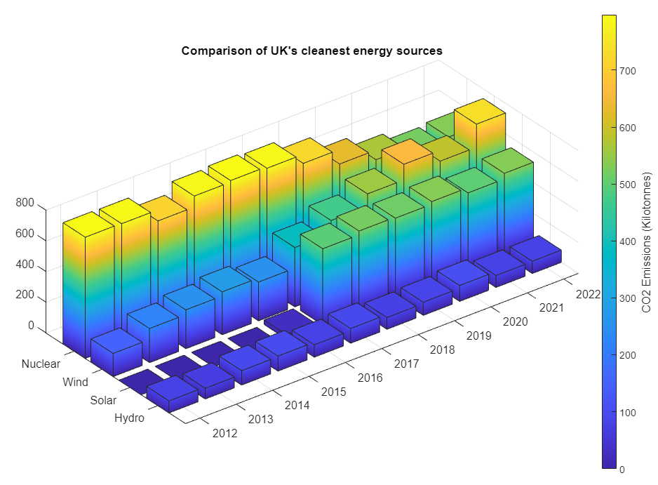Figure 9 - 3D Chart of Cleanest Energy Sources (Extra)

## Code

### 1 & 2)

% ****************** UK NATIONAL GRID: DAY, WEEK, DECADE ******************

% * By Leo Hayes *

% * Pie Charts for Power Sources and Aggregate Sources *

% * Date 14/02/2023 *

% *************************************************************************

clear;

% Cleaned GridWatch data, removed ICTs saved as new file below:

load("GridWatch_Data_19092022_SRCs.mat");

% Measure: Demand is measured in MW

% Find Total Power Share:

Total(1) = sum(biomass, "all", "omitnan");

Total(2) = sum(hydro, "all", "omitnan");

Total(3) = sum(ccgt, "all", "omitnan");

Total(4) = sum(ocgt, "all", "omitnan");

Total(5) = sum(coal, "all", "omitnan");

Total(6) = sum(pumped,"all", "omitnan");

Total(7) = sum(nuclear, "all", "omitnan");

Total(8) = sum(other, "all", "omitnan");

Total(9) = sum(solar, "all", "omitnan");

Total(10) = sum(oil, "all", "omitnan");

Total(11) = sum(wind, "all", "omitnan");

% Creating 1st Pie Chart %

explode = [1 1 0 1 1 1 1 1 1 1 1];

%ax1 = nexttile;

figure(1);

p1 = pie(Total, explode);

% Title - storing it's handle to move it's position

title("UK Power Source Share", "FontSize",16);

set(gca,'Units','normalized')

titleHandle = get( gca ,'Title' );

pos = get( titleHandle , 'position' );

pos1 = pos - [0 -0.1 0];

set( titleHandle , 'position' , pos1 );

% Adding Labels %

p1Text = findobj(p1, 'Type', 'text');

percent1Value = get(p1Text, 'String');

labels1 = {'Biomass '; 'Hydro '; 'CCGT '; 'OCGT '; 'Coal '; ...

'Pumped '; 'Nuclear '; 'Other '; 'Solar '; 'Oil '; 'Wind '};

combinedlabel1 = strcat(labels1, percent1Value);

for i = 1:length(Total)

p1Text(i).String = combinedlabel1(i);

end

set(findobj(p1,'type','text'),'FontSize', 13);

lgd1 = legend(labels1,'Location','westoutside','FontSize',14);

lgd1.Title.String = "Sources (19.09.2022)";

lg2.Title.FontSize = 12;

% Creating Aggregate Data %

% CCGT, OCGT, Coal & Oil:

Fossil_Fuels = Total(3) + Total(4) + Total(5) + Total(10);

% Biomass, Hydro, Pumped, Solar & Wind:

Renewables = Total(1) + Total(2) + Total(6) + Total(9) + Total(11);

% Nuclear:

Nuclear = Total(7);

% Other:

Other = Total(8);

Agg_Data = [Fossil_Fuels; Nuclear; Renewables; Other];

% Creating 2nd Pie Chart %

%ax2 = nexttile;

figure(2);

p2 = pie(Agg_Data);

title("Share of UK Power by category","FontSize",16);

% Adding Labels to 2nd Pie Chart %

p2Text = findobj(p2, 'Type', 'text');

percent2Value = get(p2Text, 'String');

labels2 = {'Fossil Fuels '; 'Nuclear '; 'Renewables '; 'Other '};

combinedlabel2 = strcat(labels2, percent2Value);

for i = 1:length(Agg_Data)

p2Text(i).String = combinedlabel2(i);

end

set(findobj(p2,'type','text'),'FontWeight', 'bold','FontSize', 13);

lgd2 = legend(labels2, "Location",'northwestoutside','FontSize',14);

lgd2.Title.String = "Category (19.09.2022)";

lg2.Title.FontSize = 12;

%********************************* CODE ENDS ******************************

### 3)

% ****************** UK NATIONAL GRID: DAY, WEEK, DECADE ******************

% * By Leo Hayes *

% * Area Chart for Total UK Power Demand *

% * Date 14/02/2023 *

% *************************************************************************

% Area Graph for Power usage - Monday 19th September 2022 %

clear;

% Cleaned GridWatch data, removed ICTs saved as new file below:

load("GridWatch_Data_19092022_Demand.mat");

% Preparing Data for Plot %

timestamp.Format = 'hh-mm-ss';

% Creating Area graph %

area(timestamp, demand/1000);

set(gca,'FontSize',14);

xlabel("Time (24 hrs)", "FontWeight","bold","FontSize",15);

ylabel("Power Demand in GW","FontWeight","bold","FontSize",15);

% Great Scott!

ylim([20 32]);

grid("on");

title("UK Grid Demand in 24 hour period", "FontSize",18, ...

"FontWeight", "bold");

%********************************* CODE ENDS ******************************

### 4 & 5)

% ****************** UK NATIONAL GRID: DAY, WEEK, DECADE ******************

% * By Leo Hayes *

% * Demand & Average Energy *

% * Date 14/02/2023 *

% *************************************************************************

% Monday 15th August to 22nd August 2022

clear;

% Cleaned Data for period %

load("GridWatch_Data_15082022_22082022.mat");

% Creating the required data %

date = 1:length(timestamp);

date = transpose(date);

% Creating Averages %

day_sample = 288; % 5 minute data point * 288 = 1 day

n = numel(demand); % Number of Array Elements in Demand

sub_vector = mat2cell(demand,diff([0:day_sample:n-1,n]));

% creates 1 day subvectors in a cell array and finds the mean for each

MeanCat = cellfun(@mean, sub_vector);

Days = {'Monday', 'Tuesday', 'Wednesday', 'Thursday', ...

'Friday', 'Saturday', 'Sunday'};

% Creating plot of Week vs Demand %

figure(1);

ax = gca;

plot(date/288, demand/1000);

hold("on");

daytick = 0.5:1:6.5; % For overlay of bar chart

% Bar Chart overlay shows Mean Demand for each day

Bar_Chart = bar(daytick, MeanCat/1000,'BarWidth',0.4, ...

'FaceColor', "#D95319",'FaceAlpha',0.75);

% Labels %

xlabel("15th August - 22nd August 2022", "FontWeight","bold", ...

"FontSize", 12);

ylabel("Power Demand in GW", "FontWeight","bold","FontSize",14);

lim = [0 7 20 34];

title("UK Power Demand in a Week Period", "FontSize",18, ...

"FontWeight","bold");

xticks(daytick);

xticklabels(Days);

axis(lim);

set(gca,'FontSize',14);

hold("off");

%********************************* CODE ENDS ******************************

### 6 & 7)

% ****************** UK NATIONAL GRID: DAY, WEEK, DECADE ******************

% * By Leo Hayes *

% * Decade of CO2 Emissions *

% * Date 07/03/2023 *

% *************************************************************************

clear;

load("GridWatch_Data_2012_2021_ALL.mat");

% Data - Units: MW

% Energy = MW * Hours.

% Table of Emissions - g/kWh %

sz = [7 2];

varTypes = ["string", "int16"];

varNames = ["Energy Source", "CO2 Emissions g/kWh"];

table_1 = table('Size',sz,'VariableTypes', varTypes, ...

'VariableNames', varNames);

table_1(1,:) = {'Coal', 820};

table_1(2,:) = {'Gas', 490};

table_1(3,:) = {'Nuclear', 12};

table_1(4,:) = {'Wind', 12};

table_1(5,:) = {'Solar', 48};

table_1(6,:) = {'Biomass', 230};

table_1(7,:) = {'Hydro', 24};

CO2_gram = [820; 490; 12; 12; 48; 230; 24];

% (g/kWh)Total * x = MW herefore x = 0.0833 hours, 5 minutes

% Conversion Factor: CO2_ktonne = (CO2_gram/1E6) * MW * Time_Interval

Time_Interval = 0.0833333; % 5 minutes = 0.0833333 hours

% Convert timestamp into 6 column vectors %

timeVector = datevec(timestamp);

timeYear = timeVector(:,1);

Ctrl_Group = findgroups(timeYear); % To find groups for individual years.

% Create 7x11 matrix to represent the total values of Power (MW)

Megawatts(1,:) = splitapply(@sum, coal,Ctrl_Group);

Megawatts(2,:) = splitapply(@sum, ccgt,Ctrl_Group);

Megawatts(3,:) = splitapply(@sum, nuclear, Ctrl_Group);

Megawatts(4,:) = splitapply(@sum, wind, Ctrl_Group);

Megawatts(5,:) = splitapply(@sum, solar, Ctrl_Group);

Megawatts(6,:) = splitapply(@sum, biomass, Ctrl_Group);

Megawatts(7,:) = splitapply(@sum, hydro, Ctrl_Group);

% For loop find the Mass of CO2 emissions in Kilotonnes using the following

% equation:

for i = 1:1:7

CO2_KTonnes(i,:) = (CO2_gram(i)/1E6)*(Megawatts(i,:)*Time_Interval);

end

rowNames = {'Coal', 'Gas', 'Nuclear', 'Wind', 'Solar', 'Biomass', 'Hydro'};

colNames = {'2012', '2013','2014','2015','2016','2017','2018','2019',...

'2020','2021', '2022'};

% Converting matrix to table %

format("default"); % Ensures values in matrix are default values

table_2 = array2table(CO2_KTonnes(:,:),"RowNames",rowNames, ...

"VariableNames",colNames);

disp(table_1);

disp(table_2);

%************************ Plots for CO2 Emissions ************************%

% Line Graph - All sources %

% Due to the large size of Coal & Gas these plots values are divided by a

% thousand to show Megatonnes.

figure(1);

plot(table_2{"Coal",:}/1000, "Marker", "o");

hold("on");

plot(table_2{"Gas",:}/1000, "Marker", "*");

plot(table_2{"Nuclear",:}/1000);

plot(table_2{"Wind",:}/1000);

plot(table_2{"Solar",:}/1000);

plot(table_2{"Biomass",:}/1000, "LineStyle","--","Color","#7E2F8E", ...

"Marker", "x");

plot(table_2{"Hydro",:}/1000);

xlabel("Years","FontWeight","bold","FontSize",15);

ylabel("CO2 Emissions (Megatonnes)","FontWeight","bold","FontSize", 15);

title("Total UK CO2 Emissions in the last decade", ...

"FontWeight","bold", "FontSize", 20);

xticklabels(colNames);

grid("on");

labels = {'Coal', 'Gas', 'Nuclear', 'Wind', 'Solar', 'Biomass',...

'Hydro'};

lgd1 = legend(labels);

lgd1.Title.String = 'Sources';

lgd1.FontSize = 14;

set(gca, 'FontSize', 14);

hold("off");

% Line Graph - Omitting Coal & Gas %

figure(2);

plot(table_2{"Nuclear",:},"LineStyle","-.","Color", "#77AC30", ...

"LineWidth", 1);

hold("on");

plot(table_2{"Wind",:},"LineStyle","--","Marker","*","Color","r");

plot(table_2{"Solar",:},"LineStyle","--","Color","m", ...

"Marker","o");

plot(table_2{"Biomass",:},"Marker","x");

plot(table_2{"Hydro",:},"Color","b");

xlabel("Years","FontWeight","bold","FontSize",15);

ylabel("CO2 Emissions (Kilotonnes)","FontWeight","bold","FontSize", 15);

title("Total UK CO2 Emissions omitting Coal & Gas","FontWeight", ...

"bold", "FontSize",18);

xticklabels(colNames);

grid("on");

olabels = {'Nuclear', 'Wind', 'Solar', 'Biomass', 'Hydro'};

lgd2 = legend(olabels, "Location","northwest");

lgd2.Title.String = 'Sources';

lgd2.FontSize = 14;

set(gca, 'FontSize', 14);

hold("off");

% 3D Bar Chart - Cleanest Energy %

figure(3);

z_bars = [table_2{"Nuclear",:}; table_2{"Wind",:}; ...

table_2{"Solar",:}; table_2{"Hydro",:}];

b = bar3(z_bars);

c = colorbar;

c.Label.String = 'CO2 Emissions (Kilotonnes)';

c.Label.FontSize = 13;

for k = 1:length(b)

zdata = b(k).ZData;

b(k).CData = zdata;

b(k).FaceColor = 'interp';

end

ytick = {'Nuclear', 'Wind', 'Solar', 'Hydro'};

yticklabels(ytick);

xticklabels(colNames);

set(gca, 'FontSize', 13);

title("Comparison of UK's cleanest energy sources", ...

"FontWeight","bold","FontSize",14);

%********************************* CODE ENDS ******************************

## Files

